INTERCHURCH BIOETHICS COUNCIL, 2020-2021
REPORT TO the aNGLICAN CHURCH OF AOTEAROA NEW ZEALAND AND POLYNESIA.

The InterChurch Bioethics Council (ICBC) is an ecumenical cross-cultural body supported by the Anglican, Methodist, and Presbyterian Churches of Aotearoa New Zealand. ICBC members have expertise and knowledge in science, ethics, theology, medicine, education and mātauranga Māori (Māori knowledge). Biotechnology relates to biological, medical, environmental, and agricultural technologies derived from science. Bioethics is an interdisciplinary category of ethics that provides the framework for policy and decision-making with regard to scientific research and resulting technologies; including future consequences, legal, political, commercial, theological and social aspects.

2022 represents a milestone year for the ICBC, being the 20th anniversary of the formation of this unique ecumenical body. The ICBC follows on from the “InterChurch Commission on Genetic Engineering” that was formed in 2000 to provide a Christian response to the Royal Commission on Genetic Modification. Following the governmental Royal Commission, the InterChurch Commission was renamed the “InterChurch Bioethics Council” in 2002 and was given a broader brief to raise issues relevant to the cultural, ethical, spiritual, and theological issues in the use of biotechnology in New Zealand.

Vision:
Exploring the spiritual, ethical, cultural, technological and evidential dimensions of bioethics and its consequences in Aotearoa New Zealand.

Mission Statement:
To increase the knowledge and understanding of church members and the wider community around the spiritual, ethical, cultural, technological and evidential issues relating to bioethics. To enable and encourage citizens to take action on these issues.

Our key tasks are:
- To increase our own knowledge and understanding of the interface between spirituality and biotechnology.
- To engage in consultation and dialogue with church members, community groups and specialists on the ethical, spiritual and cultural issues raised by biotechnology.
- To undertake and promote education on these issues within the community.
- To make appropriate submissions to Government and other relevant organizations on important issues of ethical and spiritual concern.
- To be an advisory body to our national church organisations by responding to requests for a positional stance on bioethical issues from our national church bodies.

For Church members the most important part of our work will be found on our website. Every congregation should include www.interchurchbioethics.org.nz as a resource. You can also find us on Facebook at www.facebook.com/InterChurchBioethicsCouncil. The website is continually updated and contains study guides, papers, and reports that can give a framework or guidelines for ethical enquiry that is separate from what appears in the mass media.

Key Tasks/Activities:
The past two years have been a busy time for the ICBC with several ethical issues being prominent in New Zealand society. On these issues, the ICBC is being asked to assist with policy statements from its member churches.

- Submissions to Government and other Organisations.

- End of Life Choice Bill Referendum
The ICBC was very active in providing information so that people could be informed as they voted in the Referendum. This included a FAQ document on the Bill, a variety of media release and articles (Anglican taonga and Touchstone) as well as several public talks.

The ICBC along with the Nathaniel Centre also produced the religious leader’s letter against the EOLC Act that was published on Sunday Sept 20 in the NZ Herald

On behalf of our supporting denominations, the ICBC also contributed $5,000 towards research undertaken by the Care Alliance to identify the key target groups, along with a contribution towards the “Risky Law” campaign. Graham O’Brien was also a member of the “Risky law” board.
Currently, co-chair Graham O’Brien along with John Kleinsman for the Nathaniel centre are working on training for the ICHC to equip Chaplains in this new context. It is hoped that training will also be of use for ministers and pastoral carers.
- Cannabis Referendum
The other major referendum in 2020 was the Cannabis law reform. Following the publication of our discussion guide on the Legalisation of Cannabis (2019) resource paper, an update was produced in August 2020. Deborah Stevens was also part of a public forum on the issue in the Christchurch Cathedral (Aug 22), along with an article in Touchstone on the issue.
- Posthumous Reproduction
In 2019 the ICBC submitted a paper to ACART on the use of Posthumous reproduction in artificial reproduction technology, in response to their public consultation document. This has been followed up with a submission to stage 2 of the consultation.

- Engage in consultation
The context of covid 19 and the subsequent vaccine is a recent area of ICBC involvement. In association with the Nathaniel Centre, the ICBC published a “ethical considerations” document on the covid vaccine, especially on the ethics of the use of human embryonic tissue in vaccine production. This paper was followed by a Frequently Asked Questions document specifically for Christian communities which has been translated into Te Reo and Samoan. The ICBC has also be involved in some email correspondence of issues related to the FAQ document.

- Undertake and promote education in the community
Initially piloted as the Bioethics Roadshow, the ICBC has supported the Centre for Science and Citizenship (CSC, www.nzcsc.org), since its inception in 2014.

An independent charitable trust. the Centre for Science and Citizenship (CSC) engages the public in exploring the ethical, cultural, and spiritual aspects of developments in science and technology. The CSC’s enQuiring minds student workshops involve several thousand intermediate and secondary students each year in age-appropriate groups ranging in size from 30 to 300 students (average 120). Workshops are highly interactive, enabling participants to think seriously about contemporary ethical issues, while enjoying lively debate and discussion.

In collaboration with Dr John Kleinsman, director of the Nathaniel Centre, the CSC facilitates Teacher Professional Development seminars for educators in faith-based schools across New Zealand. Ahead of the End-of-Life referendum, the focus of the PD in 2020 was Ethics at the end of life. In 2021 the focus is on Ethics and the Environment. The ICBC offers financial assistance for teachers and youth workers from faith-based schools to attend these professional development workshops. Six teachers have been funded to attend thus far across 2020-2021. ($1,500)

One of our members (Dr Nicola Hoggard-Creegan) is co-director of New Zealand Christians in Science, and Chair of A Rocha Aotearoa New Zealand, and the interests of ICBC, NZCIS and ARANZ all overlap. At the end of last year Nicola taught a summer course in Science and Christian theology at Otago, and this included a unit in bioethics and ecotheology. This year NZCIS hosted a seminar on teaching children science and theology, which also had a strong creation focus. Wellington Winter Lectures in June and July will feature a morning seminar at which Amy Ross will talk about philosophy of nature themes, and Nicola will speak on the importance of bioethics in her introduction to the series. In Auckland Dr. Ashley Bloomfield will deliver the third of three Winter Lectures in August on issues pertaining to faith and medicine in a pandemic. Nicola also wrote the last of the Rich Living Booklets for ARANZ on Transport. This will be made available through the website and modified as part of the upcoming emphasis on climate change.

4. Increase our own understanding

One feature of the ICBC’s role is to be informed about advancing science and technology and the issues this raises. Members have attended talks and conferences and in doing so provide reports and lead discussion to inform the whole group. The ICBC also tries to keep its website relevant with links to a range of organisations. We have also been privileged to have expert speakers attend our meetings and discuss their topics with us as we seek to upskill our own understanding and pass this on to our supporting denominations.

A priority for the work of the ICBC in 2021 is to update our documentation on climate change and write another discussion paper or provide a series of discussion papers based on different topics such as: Climate Change and Transport; Climate Change and Agriculture. Alongside this, we are continually seeking out reputable resources and websites that we can link to provide reliable information.

Membership:

As an ecumenical body we are conscious of having good representation from across our three contributing denominations, including cultural representations for Tikanga Māori and Tikanga Pacifica. Recently, we have welcomed Rev David Bush as a new Methodist member.

We also would like to acknowledge the work of Rev Dr Barbara Peddie who has stepped down from the co-chair role, and welcome Dr Joy McIntosh into that role.

We would ask our supporting denominations to look out for people with relevant skills and interests and invite them to consider joining the ICBC.

Finances
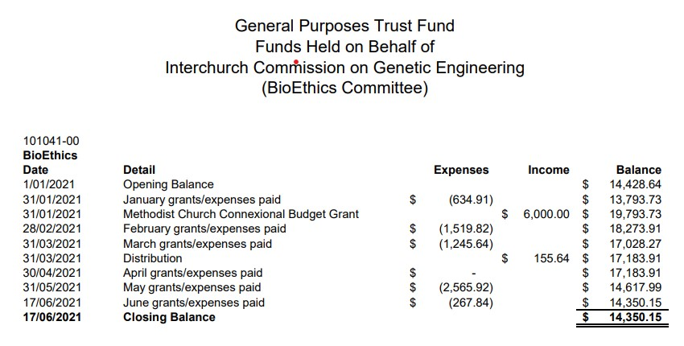

Recommendations:

As the ICBC we see ourselves as a resource for our member Churches and wider Christian community. As such we welcome opportunities to engage in discussion and provide resources. Our recommendations are:

- This Report is received.

- The Anglican members of the InterChurch Bioethics Council for the next two years will be (highlighted):

Graham O’Brien (Co-Chair; Anglican, Nelson)
Barbara Peddie (Methodist, Christchurch)
Helen Bichan (Presbyterian, Wellington)
Deborah Stevens (Anglican, Wellington)
David Bush (Methodist, Christchurch)
Tania Stuart (Anglican Auckland)
Nicola Hoggard Creegan (Anglican, Auckland)
Joy McIntosh (Co-Chair; Presbyterian, Wellington)
Filo Tu-Faleupolu (Methodist, Auckland)

We would also like to suggest a motion on the issue of climate change: That all ministry units within our supporting denominations undertake the “EcoChurch” survey developed by A Roche (https://www.ecochurch.org.nz) and choose one action point from each area to complete over the coming year.

We would like to thank the Anglican Church of Aotearoa, New Zealand and Polynesia for their continued support of the ICBC.

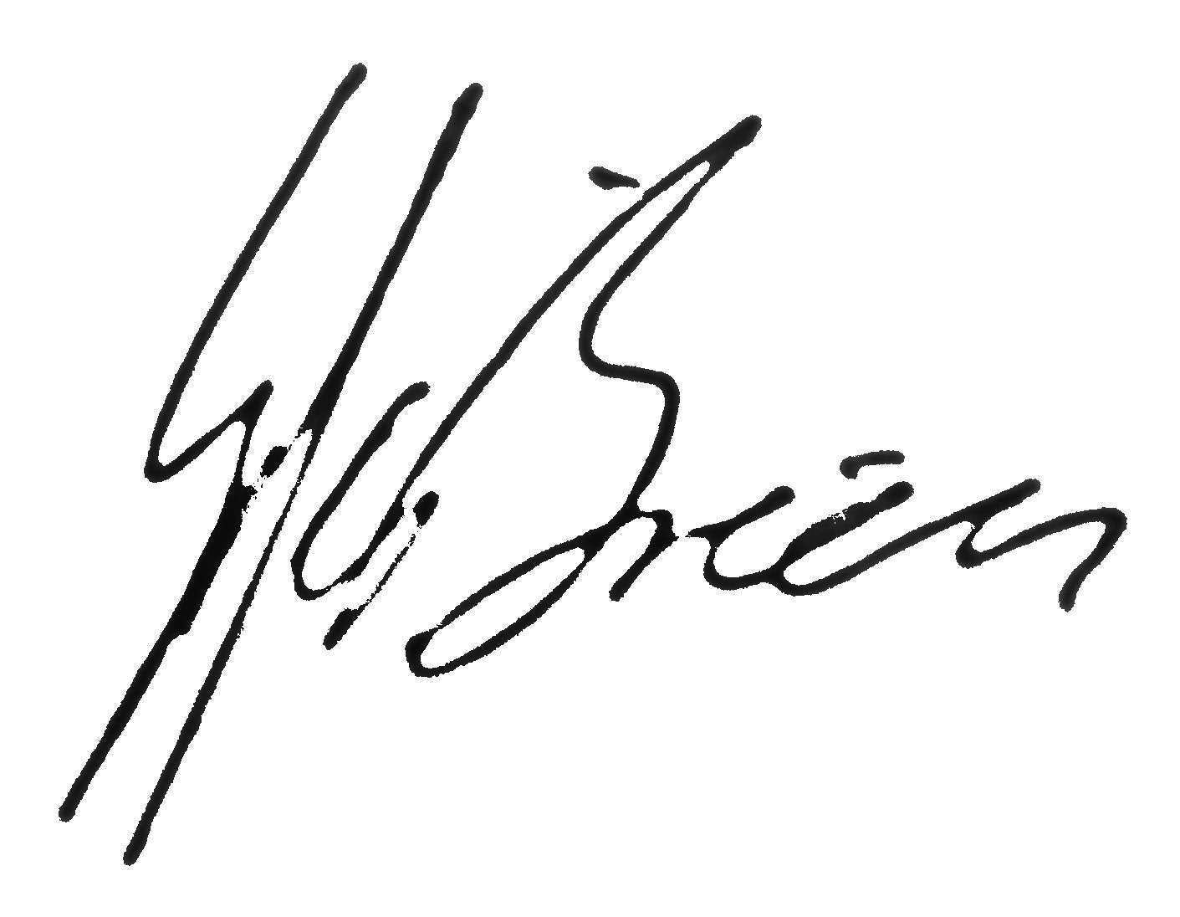


Dr Joy McIntosh and Rev Dr Graham O’Brien Co-Chairs.

June 2021.

